***HOTEL MANAGEMENT SYSTEM***

INTRODUCTION

This is a Project work undertaken in context of partial fulfilment of MCA.I have tried my best to make the complicated process of Online Hotel Management System as simple as possible using Structured & Modular technique & Menu oriented interface. I have tried to design the software in such a way that user may not have any difficulty in using this package & further expansion is possible without much effort. Even though I cannot claim that this work to be entirely exhaustive, the main purpose of my exercise is perform each Employee’s activity in computerized way rather than manually which is time consuming.

I am confident that this software package can be readily used by non-programming personal avoiding human handled chance of error. This project is used by two types of users.

1. Online Users.

1. Administrator (management of the Hotel).

Online users can see the required articles or news

Administrator can maintain daily updates in the hotel records. Administrator is must be an authorized user. He can further change the password. There is the facility for password recovery, logout etc.

The main aim of the entire activity is to automate the process of day to day activities of Hotel like Room activities, Admission of a New Customer, Assign a room according to customer’s demand, checkout of a customer and releasing the room and finally compute the bill etc.

The limited time and resources have restricted us to incorporate, in this project, only a main activities that are performed in a HOTEL Management System, but utmost care has been taken to make the system efficient and user friendly. “HOTEL MANAGEMENT SYSTEM” has been designed to computerize the following functions that are performed by the system:-

* Room related Functions
  + Opening a New Room
  + Modification to room assigned
* Check-in and check-out Detail Functions
  + Bill generation
  + Room Service
* Statement of Customer Details

OBJECTIVE

During the past several decades’ personnel function has been transformed from a relatively obscure record keeping staff to a central and top level management function. There are many factors that have influenced this transformation like technological advances, professionalism, and general recognition of human beings as most important resources.

* A computer based management system is designed to handle all the primary information required to calculate monthly statements. Separate database is maintained to handle all the details required for the correct statement calculation and generation.
* This project intends to introduce more user friendliness in the various activities such as record updating, maintenance, and searching.
* The searching of record has been made quite simple as all the details of the customer can be obtained by simply keying in the identification of that customer.
* Similarly, record maintenance and updating can also be accomplished by using
* The identification of the customer with all the details being automatically generated. These details are also being promptly automatically updated in the master file thus keeping the record absolutely up-to-date.
* The entire information has maintained in the database or Files and whoever wants to retrieve can’t retrieve, only authorization user can retrieve the necessary information which can be easily be accessible from the file.
* The main objective of the entire activity is to automate the process of day to day

Activities of Hotel like:

1. Room activities,
2. Admission of a New Customer,
3. Check into a room according to customer’s demand,
4. Check-out and releasing the room
5. Compute the bill
6. List of Regular customers.
7. Email facility.
8. Feedbacks

This project have some more **Features**:

* System Connectivity
* No data duplication
* No Paper Work Required
* Time Efficient
* Cost Efficient
* Automatic data validation
* User friendly environment
* Data security and reliability
* Fast data insertion & retrieval
* Easy performance check

ADVANTAGE

I have designed the given proposed system in the PHP to automate the process of Hotels. This project is useful for the authorities which keep track of all the users registered in a particular state. The authority can add hotel packages, room details, availability of rooms, online booking etc.

The following steps that give the detailed information of the need of proposed system are:

**Performance:** During past several decades, the records are supposed to be manually handled for all activities. The manual handling of the record is time consuming and highly prone to error. To improve the performance of the Hotel Management System, the computerized system is to be undertaken. This project is fully computerized and user friendly even that any of the members can see the report and status of the company.

**Efficiency:** The basic need of this website is efficiency. The website should be efficient so that whenever a new user submits his/her details the website is updated automatically. This record will be useful for other users instantly.

**Control:** The complete control of the project is under the hands of authorized person who has the password to access this project and illegal access is not supposed to deal with. All the control is under the administrator and the other members have the rights to just seethe records not to change any transaction or entry.

**Security:** Security is the main criteria for the proposed system. Since illegal access may corrupt the database. So security has to be given in this project.

PROJECT CATEGORY

This Project is coupled with material on how to use the various tool, sub sets available in **PHP AND MY SQL**.

Which can connect to **Relational Database** engines. This gives the programmer the opportunity to develop client server based commercial applications. These applications give users the power and ease of a GUI with the multi user capabilities of Novell, UNIX or WinNT based RDBMS engines such as MY SQL.

All the important coding techniques used by programmers, in OOPS based coding is brought out in full and in great detail.

**System Requirements**

*Hardware Requirements*

|  |  |
| --- | --- |
| Processor | Intel Core i3 Processor or Higher |
| Ram | 4GB or above |
| Hard disk | 120GB or More |
| Network Connection | 1 Mbps or Higher |

*Software Requirements*

|  |  |
| --- | --- |
| Operating System | Windows 7 or Higher |
| Language | PHP, HTML, CSS, Java |
| IDE for PHP (Server Side + Website) | Netbeans 8.1 |
| Server application | WAMP *(Windows Apache, MySQL and PHP)*  PHP 5.3 or higher with compatible MySQL. |

Gantt chart

|  |  |  |  |  |  |  |  |  |  |  |
| --- | --- | --- | --- | --- | --- | --- | --- | --- | --- | --- |
| **Task** | **Week-1** | **Week-2** | | **Week-3** | **Week-4** | **Week-5** | | **Week-6** | | **Week-7** |
| Analysis |  |  |  |  |  |  | |  | |  |
| Design |  |  |  |  |  |  | |  | |  |
| Coding |  |  | |  |  |  |  |  |  |  |
| Testing |  |  | |  |  |  | |  |  |  |

ENTITY RELATIONSHIP DIAGRAM (ERD)

**Entity – Relationship Diagram:** This depicts relationship between data objects. The attribute of each data objects noted in the entity- relationship diagram can be described using a data object description. Data flow diagram serves two purposes:

1. To provide an indication of how data are transformed as they move through the system.

2. To depict the functions that transformation the data flow.

**Data Objects:** A data object is a representation of almost any composite information that must be understood by the software. By composite information, we mean something that has a number of different properties or attributes. A data object encapsulates data only there is no reference within a data object to operations that act on the data.

**Attributes:** Attributes define the properties of a data object and take on one of three different characteristics. They can be used to:

Name an instance of data object.

Describe the instance.

Make reference to another instance in other table.

**Relationships:** Data objects are connected to one another in a variety of different ways. We can define a set of object relationship pairs that define the relevant relationships.

**Cardinality:** The data model must be capable of representing the number of occurrences of objects in a given relationship. The cardinality of an object relationship pair is

♦ **One-T0-One (1:1):** An occurrence of object ‘A’ can relate to one and only one occurrence of object ‘B’ and vice versa.

♦ **One-To-Many (1:N):** One occurrence of object ‘A’ can relate to one or may occurrences of object ‘B’ but an occurrence of object ‘B’ can relate to only one occurrence of object ‘A’.

♦ **Many-To-Many (M: N):** An occurrences of ‘B’ and an occurrence of ‘B’ can relate to one or many occurrence of ‘A’.

**Modality:** The modality of a relationship is zero if there is no explicit need for the relationship to occur or the relationship is optional. The Modality is one if the occurrence of the relationship is mandatory.

The object relationship pair can be represented graphically using the Entity Relationship Diagrams. A set of primary components are identified for the Entity Relationship Diagram,

1. Attributes,
2. Relationships and
3. Various Type Indicators.

The primary purpose of the Entity Relationship Diagram is to represent data objects and their relationships.

E-R DIAGRAM

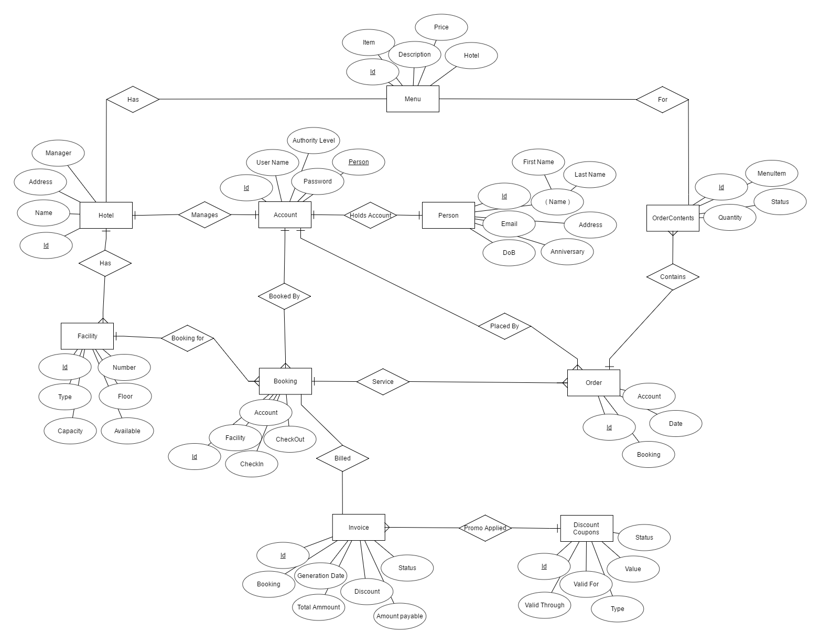

Diagram: Hotel Management ERD

Tables

Data modelling defines primary data objects, composition of each data object, and attributes of the object, relationships between each object and other objects and between objects and the processes.

**Account**

|  |  |
| --- | --- |
| Fields | Type |
| Id | Integer |
| UserName | Varchar |
| Password | Varchar |
| Person | Integer |
| Authority | Varchar |

**Person**

|  |  |
| --- | --- |
| Fields | Type |
| Id | Integer |
| FirstName | Varchar |
| LastName | Varchar |
| EmailID | Varchar |
| Address | Varchar |
| DateOfBirth | Date |
| Anniversary | Date |

**Hotel**

|  |  |
| --- | --- |
| Fields | Type |
| Id | Integer |
| Name | Varchar |
| Address | Varchar |
| Manager | Integer |

**Facility**

|  |  |
| --- | --- |
| Fields | Type |
| Id | Integer |
| Number | Integer |
| Type | Varchar |
| Floor | Integer |
| Capacity | Integer |
| Availability | Varchar |

**Menu**

|  |  |
| --- | --- |
| Fields | Type |
| Id | Integer |
| Hotel | Integer |
| Item | Varchar |
| Description | Varchar |
| Price | Float |

**Booking**

|  |  |
| --- | --- |
| Fields | Type |
| Id | Integer |
| Account | Integer |
| Facility | Integer |
| CheckIN | DateTime |
| CheckOut | DateTime |

**Order**

|  |  |
| --- | --- |
| Fields | Type |
| Id | Integer |
| Account | Integer |
| Booking | Integer |
| Date | DateTime |

**OrderContents**

|  |  |
| --- | --- |
| Fields | Type |
| Id | Integer |
| Order | Integer |
| MenuItem | Integer |
| Quantity | Integer |
| Status | Varchar |

**Invoice**

|  |  |
| --- | --- |
| Fields | Type |
| Id | Integer |
| Booking | Integer |
| GenerationDate | DateTime |
| TotalAmount | Float |
| Discount | Integer |
| AmountPayable | Float |
| Status | Varchar |

**Discount**

|  |  |
| --- | --- |
| Fields | Type |
| Id | Integer |
| Title | Varchar |
| Type | Varchar |
| Value | Float |
| ValidFor | Integer |
| ValidTill | DateTime |

CONTEXT LEVEL DFD

HOTEL MANAGEMENT SYSTEM

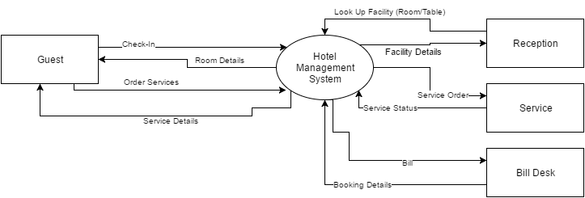

Bill generation  
Data Flow

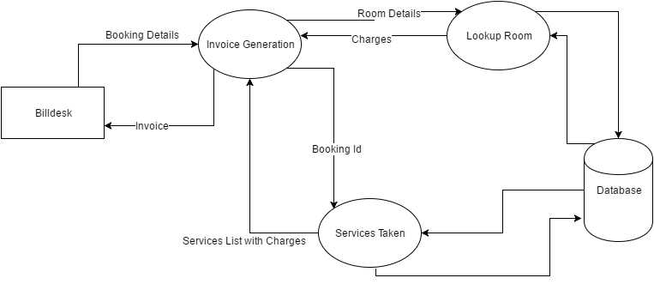

Guest Check-in

and  
Order data flow

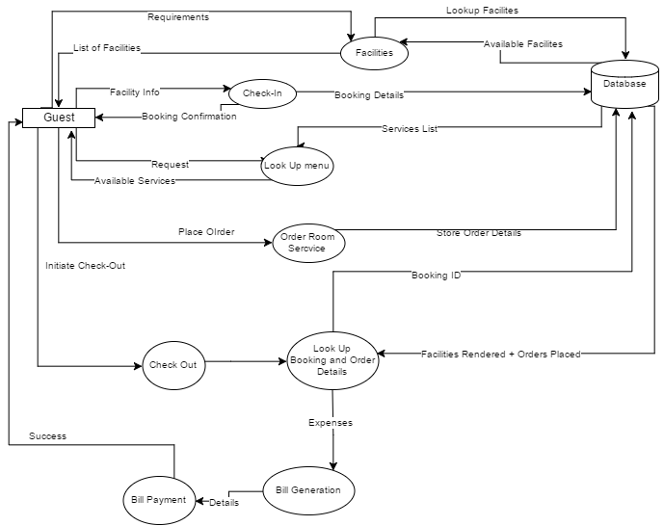

Scope of Future Application

Now a day’s hotel are providing many other facilities, this project can also be improved with the improvement in the Hotels. Utmost care and back-up procedures must be established to ensure 100% successful implementation of the computerized banking system. In case of system failure, the organization should be in a position to process the transaction with another organization or if the worst comes to the worst, it should be in a position to complete it manually.

This project can be used in the hotel after adding some more useful modules in the project for which hotel are providing services. Utmost care and back-up procedures must be established to ensure 100% successful implementation of the computerized hotel system. In case of system failure, the organization should be in a position to process the transaction with another organization or if the worst comes to the worst, it should be in a position to complete it manually.

CONCLUSION

This project is designed to meet the requirements of Online Hotel Management. It has been developed in PHP keeping in mind the specifications of the system.

For designing the system we have used simple data flow diagrams.

Overall the project teaches us the essential skills like:

 Using system analysis and design techniques like data flow diagram in designing the system.

 Understanding the database handling and query processing.

Bibliography

To bring this project to verge of completion following books and websites are being referred.

* Sams Teach Yourself PHP, MySQL and Apache All in One by Julie Meloni
* An integrated approach to Software Engineering by Pankaj Jalote
* System Analysis and Design by Elias M. Awad
* Introduction to SQL by Preeti Norton
* <http://php.net/docs>
* <http://www.w3schools.com/php/>
* <https://www.tutorialspoint.com/php/>
* <https://stackoverflow.com>
* <http://www.w3schools.com/css/>
* <https://www.tutorialspoint.com/css/>